1.Project Title: Intelligent Quiz Management System with Auto-Generated Questions
2. Project Statement and Outcomes:
The Intelligent Quiz Management System with Auto-Generated Questions is a Python-based application that allows users to take quizzes in various categories, including Academic, Entertainment, and General Knowledge. Users can choose a category, and based on their selection, relevant subcategories will be displayed (e.g., Physics, Chemistry for Academic, Sports for Entertainment, etc.). The system will dynamically generate questions using ChatGPT AI for an interactive experience. Additionally, users will have a dashboard that displays their history of completed quizzes and ongoing quizzes.
The outcome will be a fully functional quiz platform with core features such as category-based quiz selection, dynamically generated questions, a scoring system, and user history tracking. The platform will be optimized for scalability and reliability, ensuring a seamless quiz-taking experience. Extensive testing and documentation will be provided for future enhancements.
3. Modules to be Implemented:
- User Authentication & Profile Management Module
- Quiz Selection & Dynamic Question Generation Module
- Score Tracking & Dashboard Module
- Review & Documentation
4. Week-wise Module Implementation and High-Level Requirements:
Week 1-2: User & Profile Management Module
- Implement user registration, login, and authentication using Django authentication.
- Develop a database schema to store user profiles, quiz history, and scores.
- Allow users to update their profile details, including name, avatar, and preferences.
- Implement session management to maintain user login.
Week 3-4: Quiz Selection & Dynamic Question Generation Module
- Allow users to select a quiz category (Academic, Entertainment, General Knowledge).
- Display relevant subcategories based on the user's selection.
- Use ChatGPT AI to generate dynamic quiz questions for each subcategory.
- Enable users to select difficulty levels (Easy, Medium, Hard) before quiz generation.
- Implement a timer and question navigation system for a structured quiz-taking experience.
Week 5-6 :Score Tracking & Dashboard Module
- Develop a scoring system to track user performance.
- Implement a dashboard where users can view completed and incomplete quizzes.
- Display quiz scores, progress, and rankings on the dashboard.
- Provide an option to retake incomplete quizzes.
- Display quiz results upon completion, including correct/incorrect answers.
- Use AI to generate reference links or explanations for incorrect answers to support user learning.
Week 7-8 : Testing, Review, and Documentation
- Conduct a thorough review of the entire system, including functionality, security, and user interface.
- Address any identified bugs or issues and perform necessary fixes.
- Prepare comprehensive documentation covering system architecture, user guides, and technical specifications.

.

5. Flow chart:

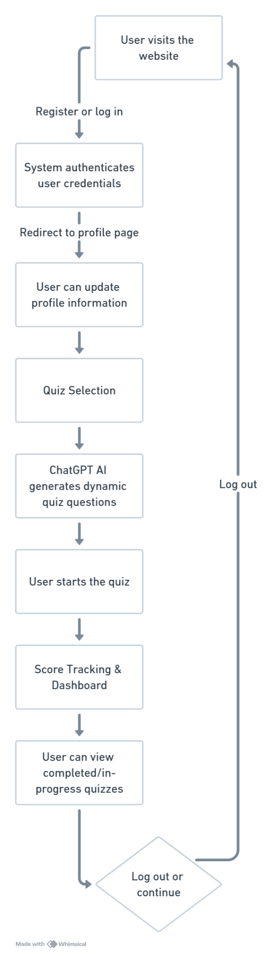
6. Sample Dashboard
